### Exercise 1: Sum of Array Elements

### Write a function sumArray(arr) that takes an array of numbers as an argument and returns the sum of all elements in the array.

function sumArray(arr){

    let sum=0;

    for (let i=0;i<arr.length;i++){

        sum+=arr[i];

    }

    console.log("Given array is:")

    console.log(arr);

    console.log("Sum of array elements is: "+sum);

}

var x=[3,5,7,9,11,15];

sumArray(x);

Output:

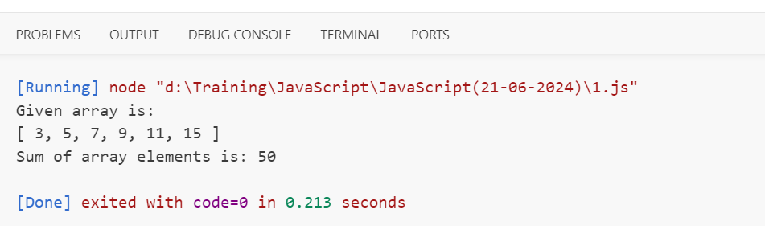

Exercise 2: Reverse a String

Write a function reverseString(str) that takes a string as an argument and returns the reversed version of the string.

function reverseString(str){

    let s="";

    for (let i=str.length-1;i>=0;i--){

        s+=str[i];

    }

    console.log("Given string is: "+str);

    console.log("Reverse of string is: "+s);

}

var x="Java Script"

reverseString(x);

Output:

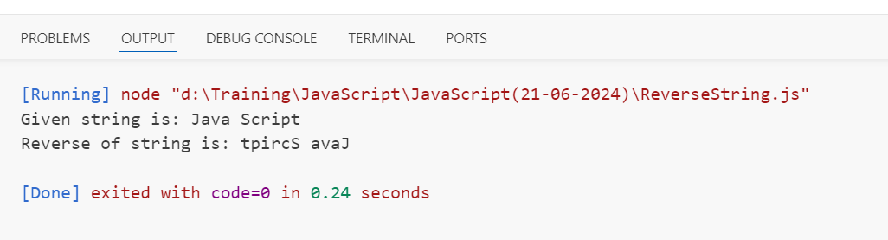

Exercise 3: Find the Largest Number

Write a function findLargest(arr) that takes an array of numbers as an argument and returns the largest number in the array.

function findLargest(arr){

    let largest = arr[0];

    for (let i = 1; i < arr.length; i++){

        if (arr[i] > largest){

            largest = arr[i];

        }

    }

    console.log("Given array is: ");

    console.log(arr);

    console.log("Largest number in array is: " + largest);

}

var a = [10, 20, 11, 3, 52, 29, 30];

findLargest(a);

Output:

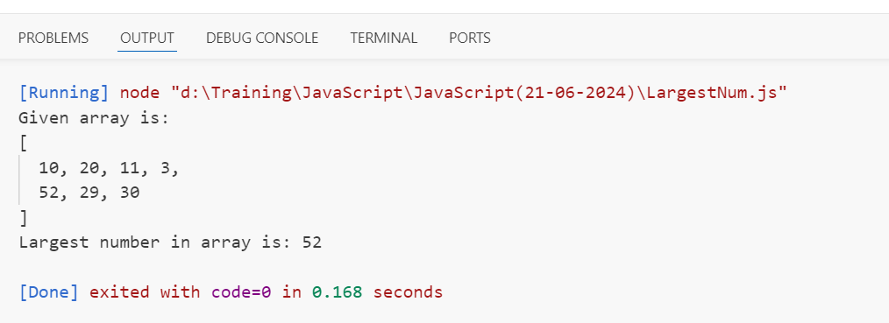

Exercise 4: Palindrome Checker

Write a function isPalindrome(str) that takes a string as an argument and returns true if the string is a palindrome (reads the same backward as forward), and false otherwise. Ignore spaces, punctuation, and capitalization.

function isPalindrome(str) {

    let s = "";

    for (let i = str.length-1; i >= 0; i--) {

        s += str[i];

    }

    if  (str == s) {

        console.log(true);

    }

    else {

        console.log(false);

    }

}

let a = "racecar";

console.log("Given string is: " + a);

console.log(a + " is a palindrome")

isPalindrome(a);

Output:

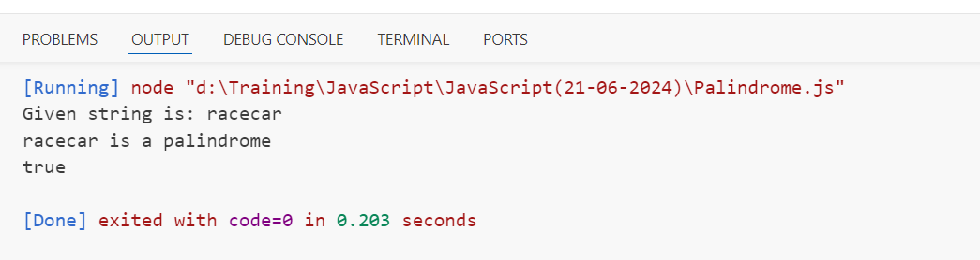

Exercise 5: FizzBuzz

Write a function fizzBuzz(n) that prints the numbers from 1 to n. But for multiples of three, print "Fizz" instead of the number, and for the multiples of five, print "Buzz". For numbers which are multiples of both three and five, print "FizzBuzz".

function fizzBuzz(n) {

    for (let i = 1; i <= n; i++) {

        if (i % 3 == 0 && i % 5 == 0) {

            console.log("FizzBuzz");

        }

        else if (i % 3 == 0) {

            console.log("Fizz");

        }

        else if (i % 5 == 0) {

            console.log("Buzz");

        }

    }

}

fizzBuzz(15);

Output:

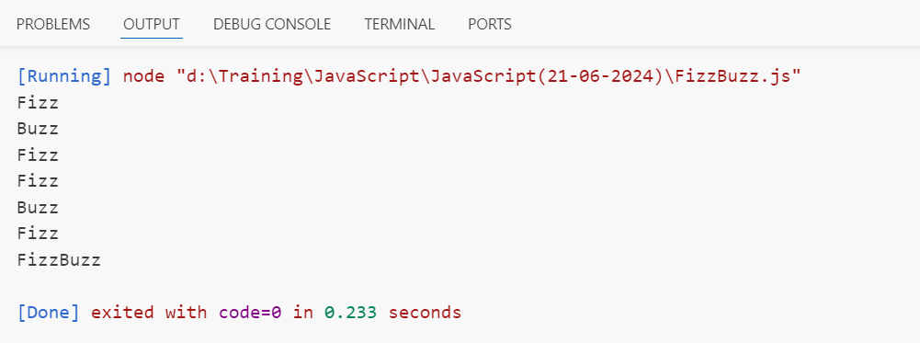

Exercise 6: Factorial Calculation

Write a function factorial(n) that calculates the factorial of a number. The factorial of a number is the product of all positive integers less than or equal to that number. For example, the factorial of 5 is 5 * 4 * 3 * 2 * 1.

function factorial(n) {

   if (n == 1) {

    console.log("factorial of 1 is : 1");

   }

    let fact = 1;

    for (let i = 2; i <= n; i++) {

        fact *= i;

    }

    console.log("Factorial of " + n + " is: " + fact);

}

factorial(6);

Output:

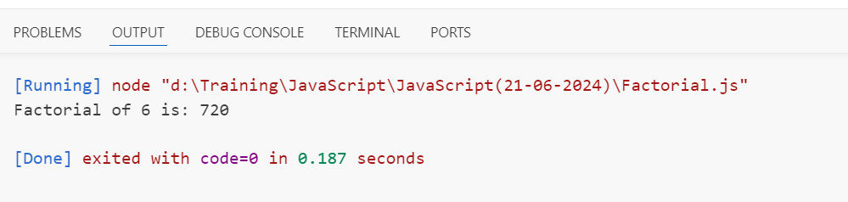

### Exercise 7: Prime Number Checker

### Write a function isPrime(n) that takes a number as an argument and returns true if the number is a prime number (a number greater than 1 that has no divisors other than 1 and itself), and false otherwise.

function isPrime(n) {

    let prime = true;

    for (let i = 2; i < n; i++) {

        if (n % i == 0) {

            prime = false;

            break;

        }

    }

    console.log(n + " is a prime number");

    if (prime == true) {

        console.log(true);

    }

    else {

        console.log(false);

    }

}

isPrime(4);

isPrime(11);

Output:

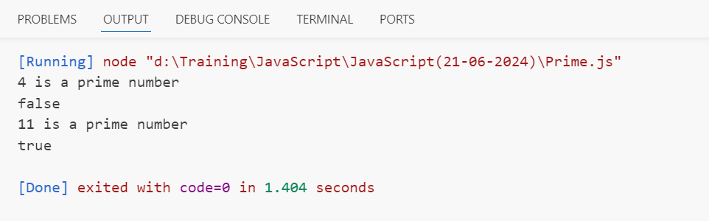

### Exercise 8: Array Chunking

### Write a function chunkArray(arr, chunkSize) that splits an array into smaller arrays of a specified size chunkSize.

function chunkArray(arr, chunkSize) {

    let x = [];

    for (let i = 0; i < arr.length; i += chunkSize) {

        let y = arr.slice(i, i + chunkSize);

        x.push(y);

    }

    console.log("Given array is:");

    console.log(arr);

    console.log("After splitting into smaller arrays with size " + chunkSize + " is:");

    console.log(x);

}

var a = [1, 2, 3, 4, 5, 6, 7, 8, 9, 10];

chunkArray(a, 3);

Output:

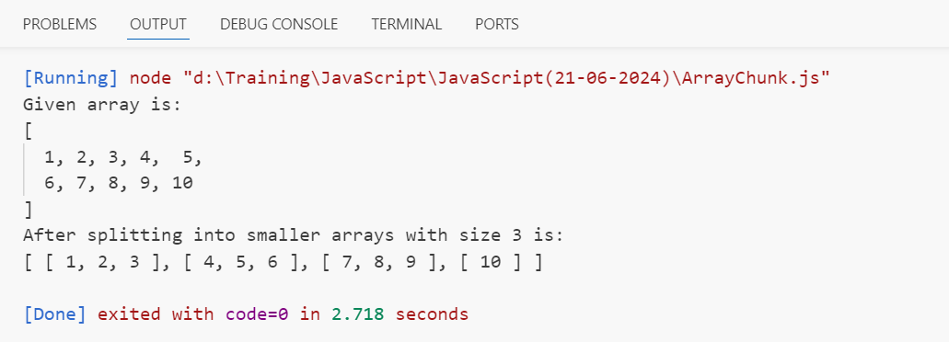

### Exercise 9: Capitalize Letters

### Write a function capitalizeLetters(str) that takes a string as an argument and returns the string with all letters capitalized.

function capitalizeLetters(str) {

    let s = str.toUpperCase();

    console.log("Given string is: " + str);

    console.log("The strng with all letters capitalized is: " + s);

}

capitalizeLetters("Greemus Software");

Output:

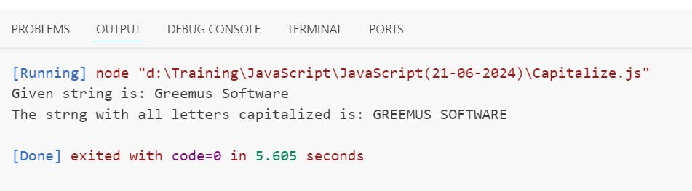

Exercise 10: Anagram Checker

Write a function isAnagram(str1, str2) that takes two strings as arguments and returns true if they are anagrams of each other (contain the exact same characters with the same frequencies), and false otherwise.

function isAnagram(str1, str2) {

    console.log(str1 + " and " + str2 + " are anagrams");

    if (str1.length == str2.length) {

        let anag = true;

        for (let i = 0; i < str1.length; i++) {

            if (!str2.includes(str1[i])) {

                anag = false;

            }

        }

        console.log(anag);

    }

    else {

        console.log(false);

    }

}

isAnagram("bare", "bear");

Output:

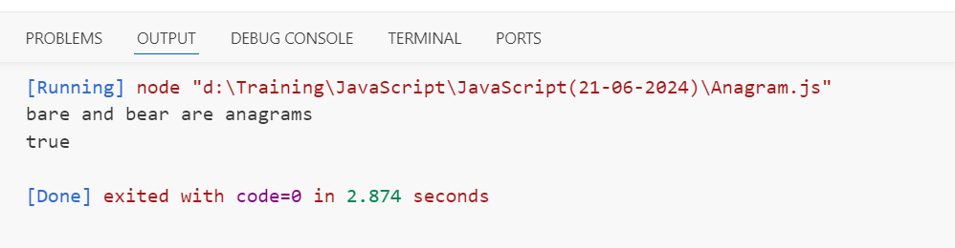

### Exercise 11: Count Vowels

Write a function countVowels(str) that takes a string as an argument and returns the number of vowels (a, e, i, o, u) in the string.

function countVowels(str) {

    let vowels = "AaEeIiOoUu";

    let count = 0;

   for (let i = 0; i < str.length; i++) {

        if (vowels.includes(str[i])) {

            count += 1;

        }

   }

    console.log("Number of vowels in " + str + " are: " + count);

}

countVowels("International");

countVowels("Umbrella");

Output:

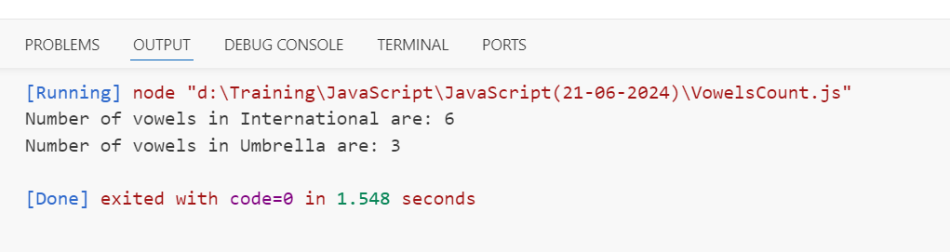

### Exercise 12: Find the Longest Word

Write a function findLongestWord(str) that takes a string of words separated by spaces and returns the longest word in the string. If there are multiple words with the same length, return the first one.

function findLongestWord(str) {

    let s = str.split(" ");

    let longest = s[0];

    for (let i = 1; i < s.length; i++) {

        if ( s[i].length > longest.length) {

            longest = s[i];

        }

    }

    console.log("Given string is: " + str);

    console.log("The longest word in string is: " + longest);

}

var a = "HTML stands for Hyper Text Markup Language";

findLongestWord(a);

Output:

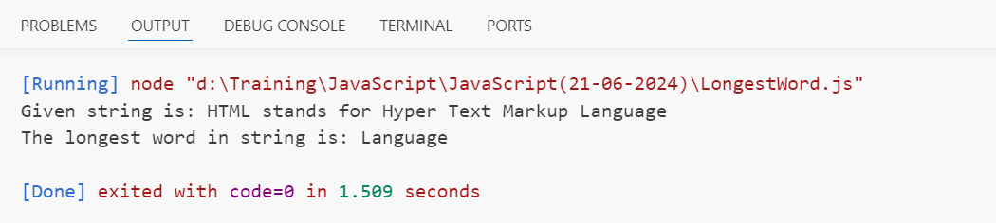

### Exercise 13: Title Case a Sentence

Write a function titleCase(str) that takes a string and returns the string with the first letter of each word capitalized.

function titleCase(str) {

    let s = str.split(" ");

    let final = "";

    for (let i = 0; i < s.length; i++) {

        x = s[i];

        let cap = x[0].toUpperCase();

        let s2 = "";

        for (let j = 1; j <x.length; j++) {

            s2 += x[j];

        }

        x = cap + s2;

        final = final.concat(x + " ");

    }

    console.log("Given sentence is :");

    console.log(str);

    console.log("Sentence with first letter of each word is capitalized is:");

    console.log(final);

}

var a = "i am working at greemus";

titleCase(a);

Output:

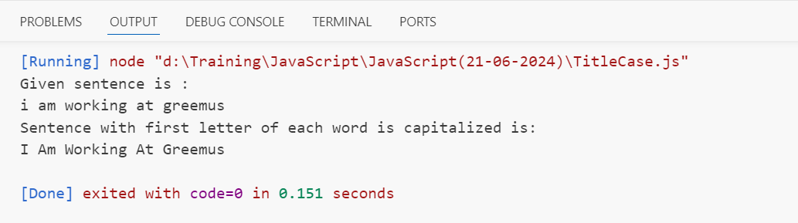

### Exercise 14: Sum of Multiples

Write a function sumMultiples(n) that takes a number n and returns the sum of all multiples of 3 and 5 up to n.

function sumMultiples(n) {

    let sum = 0;

    for (let i = 1; i <= n; i++) {

        if (i % 3 == 0 || i % 5 == 0) {

         sum += i;

    }

}

console.log("Sum of all multiples of 3 and 5 up to " + n + " is: " + sum);

}

sumMultiples(10);

Output:

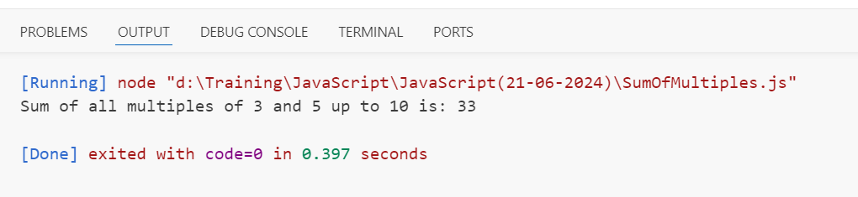

### Exercise 15: Fibonacci Sequence

Write a function fibonacci(n) that generates an array of the first n numbers in the Fibonacci sequence.

function fibonacci(n) {

    let s = [0, 1];

    if(n <= 1) {

        return s;

    }

    while (s.length < n) {

        s.push(s[s.length-1]+s[s.length-2]);

    }

    console.log("The fibonacci series of first "+ n + " numbers is: " + s);

}

fibonacci(8);

Output:

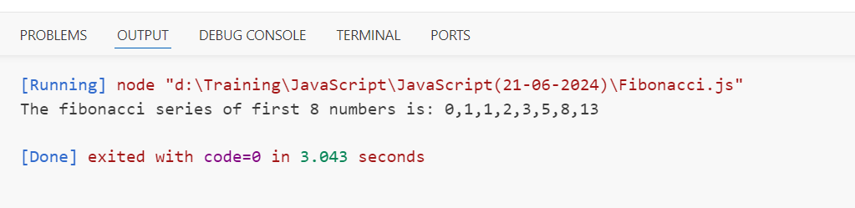

### Exercise 16: Find Odd Numbers

Write a function findOddNumbers(arr) that takes an array of numbers and returns an array containing only the odd numbers.

function findOddNumbers(arr) {

    let odd = [];

    for (let i = 0; i < arr.length; i++) {

        if (arr[i] % 2 != 0) {

            odd.push(arr[i]);

        }

    }

    console.log("Given array is: ");

    console.log(arr);

    console.log("Array of odd numbers of given array is: ");

    console.log(odd);

}

var x = [5, 2, 4, 8, 7, 10, 14, 19, 1];

findOddNumbers(x);

Output:

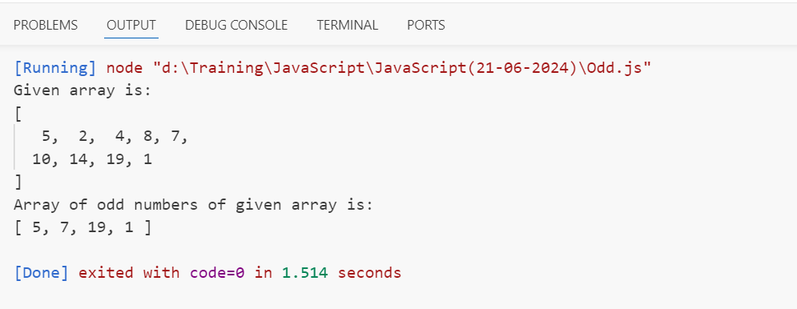

### Exercise 17: Remove Duplicates

Write a function removeDuplicates(arr) that takes an array and returns a new array with all duplicates removed.

function removeDuplicates(arr) {

    let unique = [];

    arr.forEach(element => {

        if (!unique.includes(element)) {

            unique.push(element);

            }

        });

        console.log("Given array is:");

        console.log(arr);

        console.log("Array after removing duplicates is:");

        console.log(unique);

}

var a = [7, 3, 9, 10, 4, 2, 7, 7, 5, 3, 9];

removeDuplicates(a);

Output:

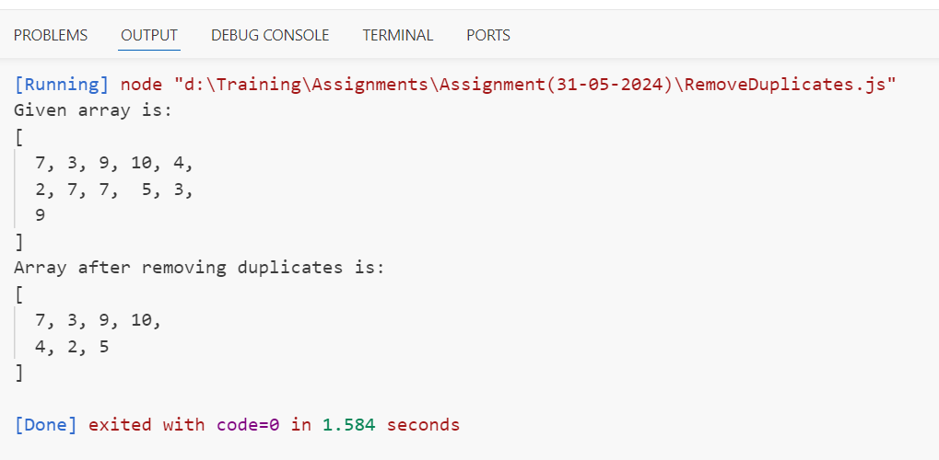

### Exercise 18: Capitalize Words

Write a function capitalizeWords(sentence) that takes a sentence (string) and capitalizes the first letter of each word.

function capitalizeWords(sentence) {

    let s = sentence.split(" ");

    let final = "";

    for (let i = 0; i < s.length; i++) {

        str = s[i];

        let cap = str[0].toUpperCase();

        let s2 = "";

        for (let j = 1; j <str.length; j++) {

            s2 += str[j];

        }

        str = cap + s2;

        final = final.concat(str + " ");

    }

    console.log("Given sentence is :");

    console.log(sentence);

    console.log("Sentence with first letter of each word is capitalized is:");

    console.log(final);

}

var a = "i am working at greemus";

capitalizeWords(a);

Output:

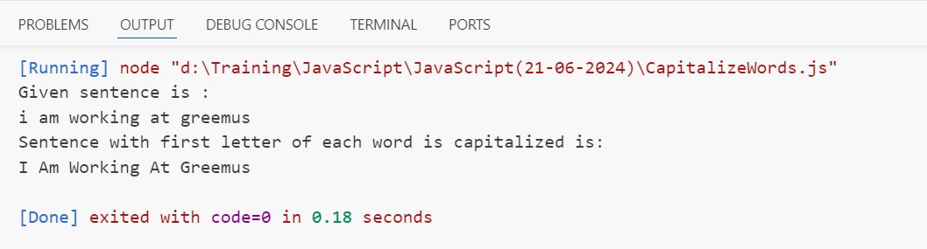

### Exercise 19: Reverse Words

Write a function reverseWords(sentence) that takes a sentence (string) and reverses the order of words.

function reverseWords(sentence) {

    let s = sentence.split(" ");

    let reverse = "";

    for (let i = s.length-1; i >= 0; i--) {

        reverse = reverse.concat(" " + s[i]);

    }

    console.log("Given sentence is: ");

    console.log(sentence);

    console.log("Sentence with reversed order of words is:");

    console.log(reverse);

}

var a = "HTML is a front end language";

reverseWords(a);

Output:

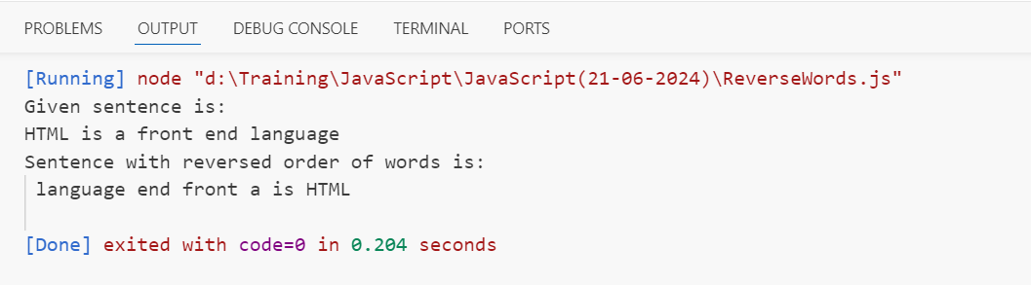

### Exercise 20: Count Characters

Write a function countCharacters(str) that takes a string and returns an object where keys are characters in the string and values are the counts of those characters.

function countCharacters(str) {

    console.log("Given string is: " + str);

    console.log("Object with characters and their count as keys and values is:");

    for (let i = 0; i < str.length; i++){

        let count = 0;

        for (let j = 0; j < str.length; j++){

            if (str[i] == str[j]) {

                count += 1;

            }

        }

        console.log(str[i] + ":" + count);

    }

}

countCharacters("GREEMUS");

Output:

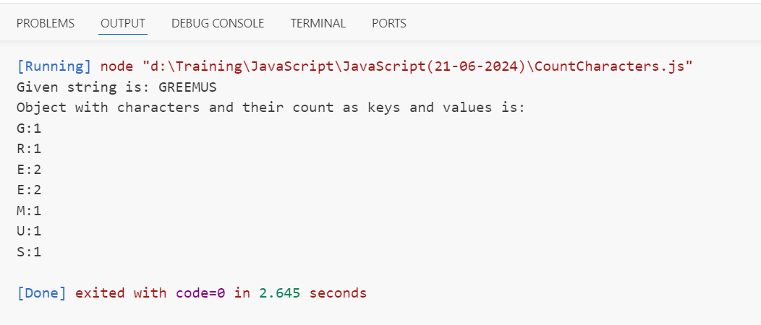

### Exercise 21: Check Armstrong Number

Write a function isArmstrongNumber(num) that takes a number as an argument and returns true if it is an Armstrong number, otherwise false. An Armstrong number (or narcissistic number) is a number that is equal to the sum of its own digits each raised to the power of the number of digits.

function isArmstrongNumber(num) {

    let str = num.toString();

    let n = str.length;

    let sum = 0;

    for (let i = 0; i < n; i++) {

        sum += str[i]**n;

    }

    console.log(num + " is an armstrong number");

    if (num == sum) {

        console.log(true);

    }

    else {

        console.log(false);

    }

}

isArmstrongNumber(153);

isArmstrongNumber(150);

Output:

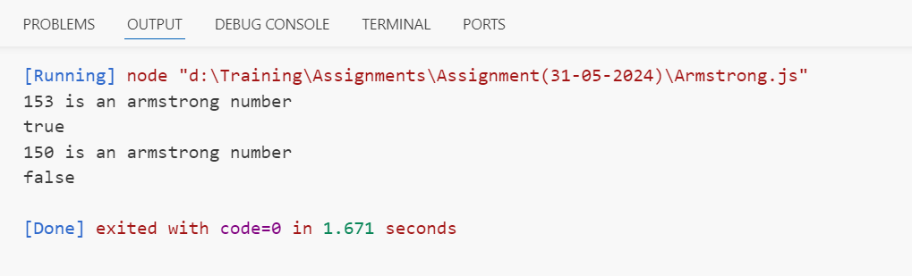

### Exercise 22: Validate Email Address

Write a function validateEmail(email) that takes an email address as a string and returns true if it is a valid email address format, otherwise false.

function validateEmail(email) {

    let x = "@";

    let y = ".com";

    let z = " ";

    console.log(email + " is a valid email");

    if (email.includes(x, y) && !email.includes(z)) {

        console.log(true);

    }

    else {

        console.log(false);

    }

}

validateEmail("potlapula.nithish@gmail.com");

validateEmail("nithish.p.com");

validateEmail("nith ish.p@gmail.com");

Output:

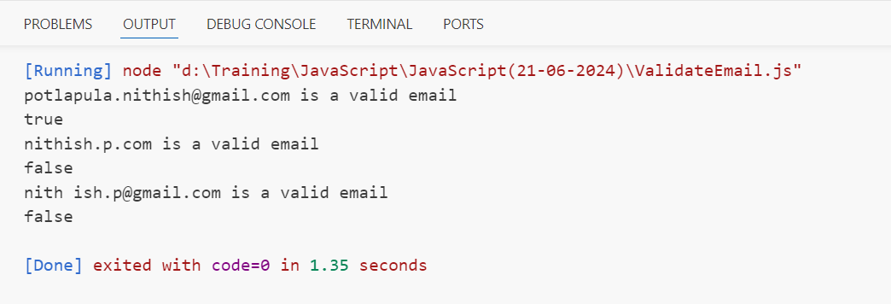

### Exercise 23: Binary to Decimal Conversion

Write a function binaryToDecimal(binary) that converts a binary number (given as a string) to a decimal number.

function binaryToDecimal(binary) {

      let decimal = 0;

      let l = binary.length;

      for (let i = l - 1; i >= 0; i--) {

         if ( binary[i] == '1' )

         decimal += Math.pow( 2, l - 1 - i );

      }

      console.log("The decimal number of " + binary + " is: " + decimal);

      }

binaryToDecimal("110");

Output:

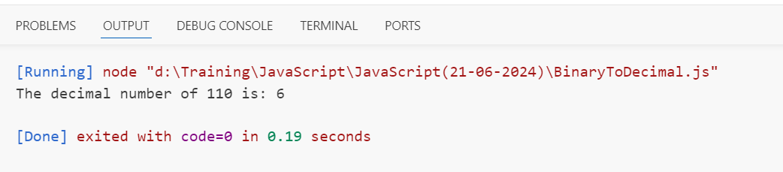

### Exercise 24: Count Words

Write a function countWords(sentence) that takes a sentence (string) and returns the number of words in the sentence.

function countWords(sentence) {

    let s = sentence.split(" ");

    let count = s.length;

    console.log("Given sentence is:");

    console.log(sentence);

    console.log("Number of words in the sentence are: " + count);

}

var x = "AngularJS is a framework and ReactJS is a library of JavaScript";

countWords(x);

Output:

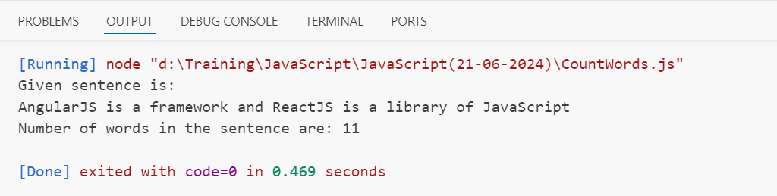

### Exercise 25: Intersection of Arrays

Write a function arrayIntersection(arr1, arr2) that takes two arrays and returns an array containing elements that are present in both arrays.

function arrayIntersection(arr1, arr2) {

    let a=[];

    for(let i=0;i<arr1.length;i++){

        if(arr2.includes(arr1[i])){

            a.push(arr1[i]);

        }

    }

    console.log("Given arrays are:");

    console.log(arr1);

    console.log(arr2);

    console.log("Common elements of both arrays are:");

    console.log(a);

}

let x = ["A", "B", "H", "J", "M", "K", "O"];

let y = ["D", "G", "A", "O", "C", "H", "B"];

arrayIntersection(x, y);

Output:

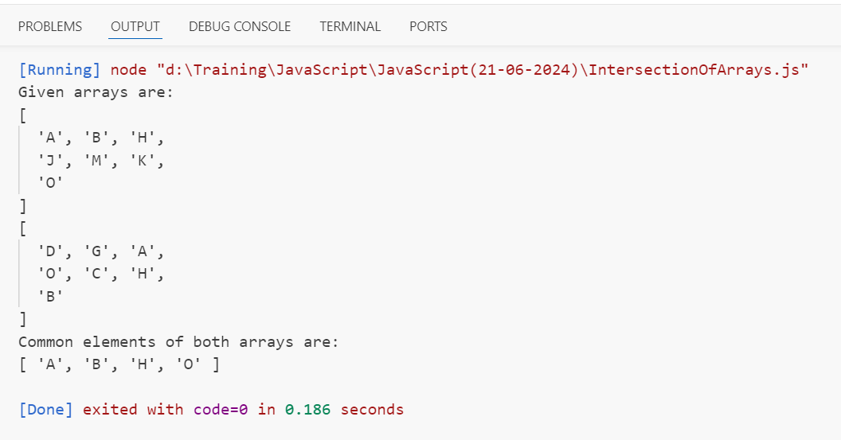

### Exercise 26: Sum of Squares

Write a function sumOfSquares(n) that calculates the sum of squares of all integers from 1 to n.

function sumOfSquares(n) {

    let sum = 0;

    for (let i = 1; i <= n; i++) {

        let s = i * i;

        sum += s;

    }

    console.log("Sum of squares of numbers from 1 to " + n + " is: " + sum);

}

sumOfSquares(5);

Output:

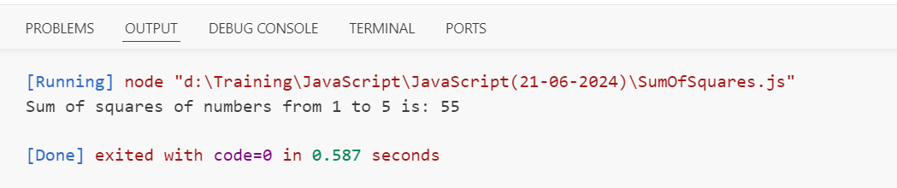

### Exercise 27: Caesar Cipher

Write a function caesarCipher(str, shift) that takes a string and a number (shift) and returns a new string where each character in the original string is shifted shift positions in the alphabet.

function caesarCipher(str, shift) {

    let s = "";

    let alp = "abcdefghijklmnopqrstuvwxyz";

    for (let i = 0; i < str.length; i++) {

        let x = alp.indexOf(str[i]);

        s += alp[x + shift];

    }

    console.log("Given string is: " + str);

    console.log("After shifting each character " + shift + " positions in alphabet is :" + s);

}

caesarCipher("nithish", 3);

Output:

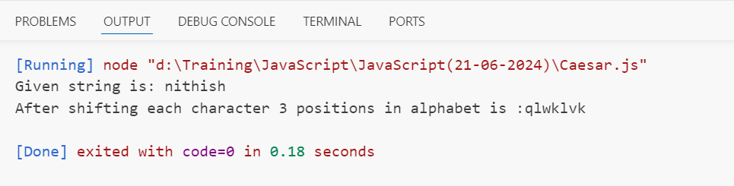

### Exercise 28: Remove Falsy Values

Write a function removeFalsyValues(arr) that takes an array and returns a new array with all falsy values removed (false, null, 0, "", undefined, and NaN).

function removeFalsyValues(arr) {

    let final = [];

    let falsy = [false, 0, "", null, undefined, NaN];

    for (let i = 0; i < arr.length; i++) {

        if (!falsy.includes(arr[i])) {

            final.push(arr[i]);

        }

    }

    console.log("Given array is:");

    console.log(arr);

    console.log("After removing falsy values is:");

    console.log(final);

}

var a = [10, "ABC", false, "", undefined, NaN, null, true, 500];

removeFalsyValues(a);

Output:

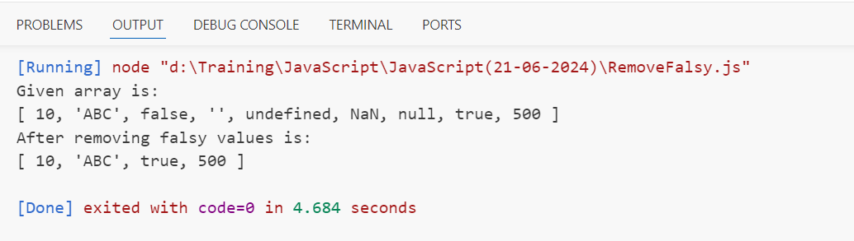

### Exercise 29: Validate Palindrome

Write a function validatePalindrome(str) that takes a string and returns true if it is a palindrome (ignoring spaces, punctuation, and capitalization), otherwise false.

function isPalindrome(str) {

    let s = "";

    for (let i = str.length-1; i >= 0; i--) {

        s += str[i];

    }

    if  (str == s) {

        console.log(true);

    }

    else {

        console.log(false);

    }

}

let a = "racecar";

console.log("Given string is: " + a);

console.log(a + " is a palindrome")

isPalindrome(a);

Output:

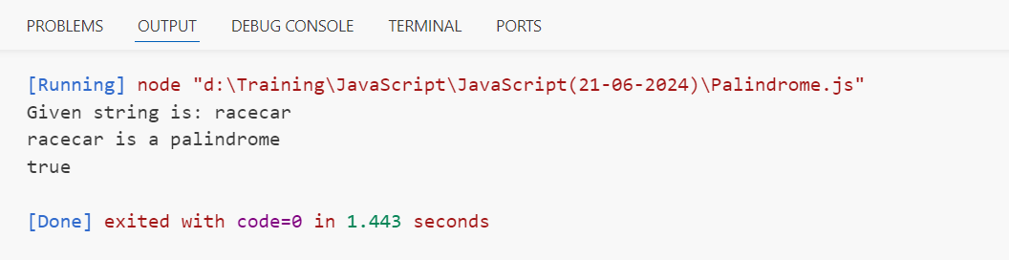

### Exercise 30: Find Missing Number

Write a function findMissingNumber(arr) that takes an array containing n distinct numbers taken from the range 0 to n, and returns the missing number.

function findMissingNumber(arr) {

    let largest = arr[0];

    for (let i = 0; i < arr.length; i++){

        if (arr[i] > largest){

            largest = arr[i];

        }

    }

    let a = [];

    for (let i = 0; i <= largest; i++) {

        a.push(i);

    }

    let missing = 0;

    a.forEach(element => {

        if (!arr.includes(element)){

            missing = element;

        }

    });

    console.log("Given array is:");

    console.log(arr);

    console.log("Mising element is: " + missing);

}

var x = [3, 6, 1, 2, 5, 0, 4, 10, 7, 9];

findMissingNumber(x);

Output:

